ACROPOLIS INSTITUTE OF TECHNOLOGY AND

RESEARCH

**Department of IT, CSE (DS), CSE (IoT)**

# Synopsis

On

***KYC (Know Your College)***

***BRIDGING THE INFORMATION GAP IN COLLEGE CO-CURRICULAR ACTIVITIES***

**Introduction:**

Overview:

College events play a crucial role in the lives of college students, providing them with valuable opportunities for personal growth, community engagement, and skill development. These events serve as a platform for students to connect with their peers and exchanging of ideas, perspectives, and experiences that contribute to their overall development.

One of the major benefits of participating in college events is the chance to upskill oneself. These events often feature workshops, seminars, and lectures conducted by experts in various fields. By attending these sessions, students not only enhance their skill set but also gain exposure to emerging technologies and trends. This exposure enables them to stay updated with the latest advancements in their respective areas of interest and encourages further exploration and learning.

College events serve as a knowledge hub, bringing in speakers who share insights into various topics. This exposure to different perspectives and subjects can ignite students curiosity and inspire them to search about the areas and technologies they may not have encountered before. Whether it is a discussion on technology or a discussion on a niche topic, these events widen students mind and encourage them to explore beyond academic studies

Purpose:

The purpose of this project is to improve communication and engagement among college students by providing them with a convenient and centralized platform to access information about upcoming events. By using this application, students will be able to plan and participate in events that align with their interests.

Literature Survey:

Existing Problem:

The current problem is we have is that sometimes the information isn’t spread to the students properly. The current distribution of information about events is that of spreading through word of mouth which is going in every classroom and announcing them. Sometimes students are absent during the announcement of the event so in that case the information doesn’t reaches to the student. Sometimes teachers post about them on noticeboards or emails the student about them but they are mostly ineffective and inefficient way of conveying information.

Existing approaches or methods to solve this problem:

The solution we proposed is building an user friendly mobile application which has a similar interface to Instagram since it’s the most widely used social media app so the interface will be very user friendly and easy to use. It being an app is a big comfort for students since they don’t have to go to noticeboards to see the information or check emails they will just need to open app which will then provide each and every information about desired events and the contact of the event head as well.

Proposed Solution:

**User-Friendly Interface**:

Our application prioritizes user-friendliness. Its interface is based of Instagram’s interface because of its user friendliness since most students use Instagram.

**Seamless Navigation**:

The application's design places a strong emphasis on seamless navigation. With a few taps, students can quickly browse through a lot of upcoming events, ranging from academic seminars to cultural festivals and sports competitions. This streamlined navigation ensures that students can quickly identify events that align with their interests.

**Event Registration**:

We understand that participation is a key aspect of event engagement. Hence, our application offers event registration options. Students can sign up for events of their choice effortlessly.

**Event Feedback**:

We value the opinions and feedback of our student users. Our application includes a feature that allows students to provide feedback after attending events. This feedback loop enables continuous improvement, ensuring that future events are tailored to the preferences of our vibrant student community.

**Interactive Chat**:

Through the integrated chat functionality, students can connect with their peers, collaborate on projects or initiatives.

# Theoretical Analysis

Block Diagram:

The block diagram of the project showcases the flow of information from event organizers to the application users. It illustrates the different components involved in the system, including the event management system, database, and user interface.

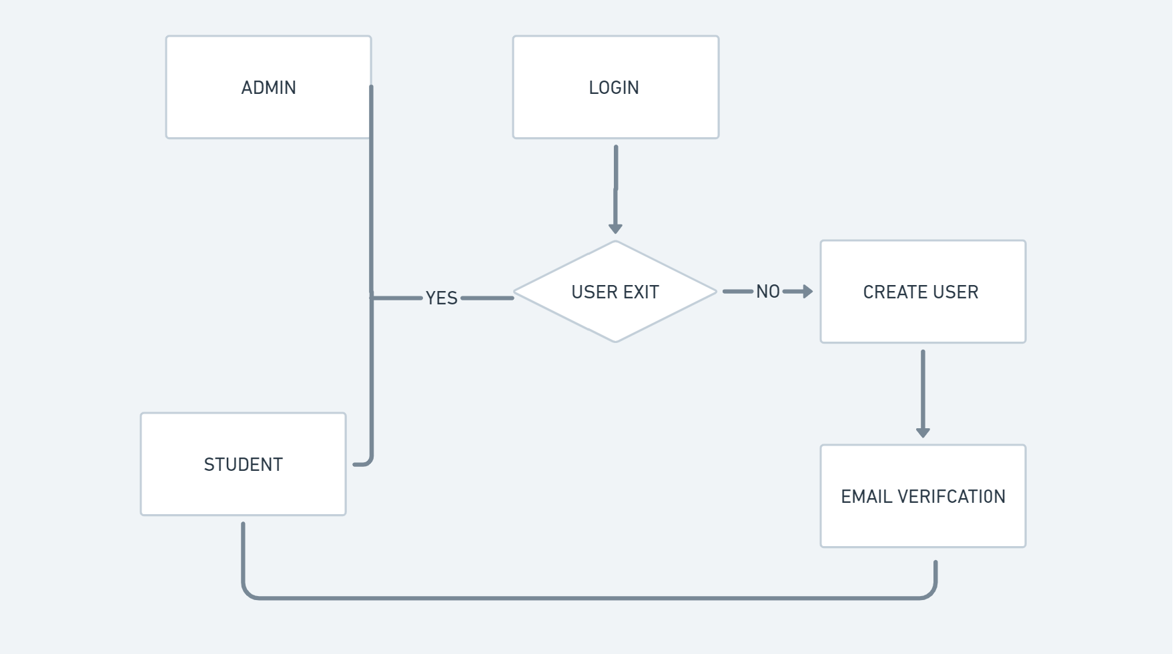

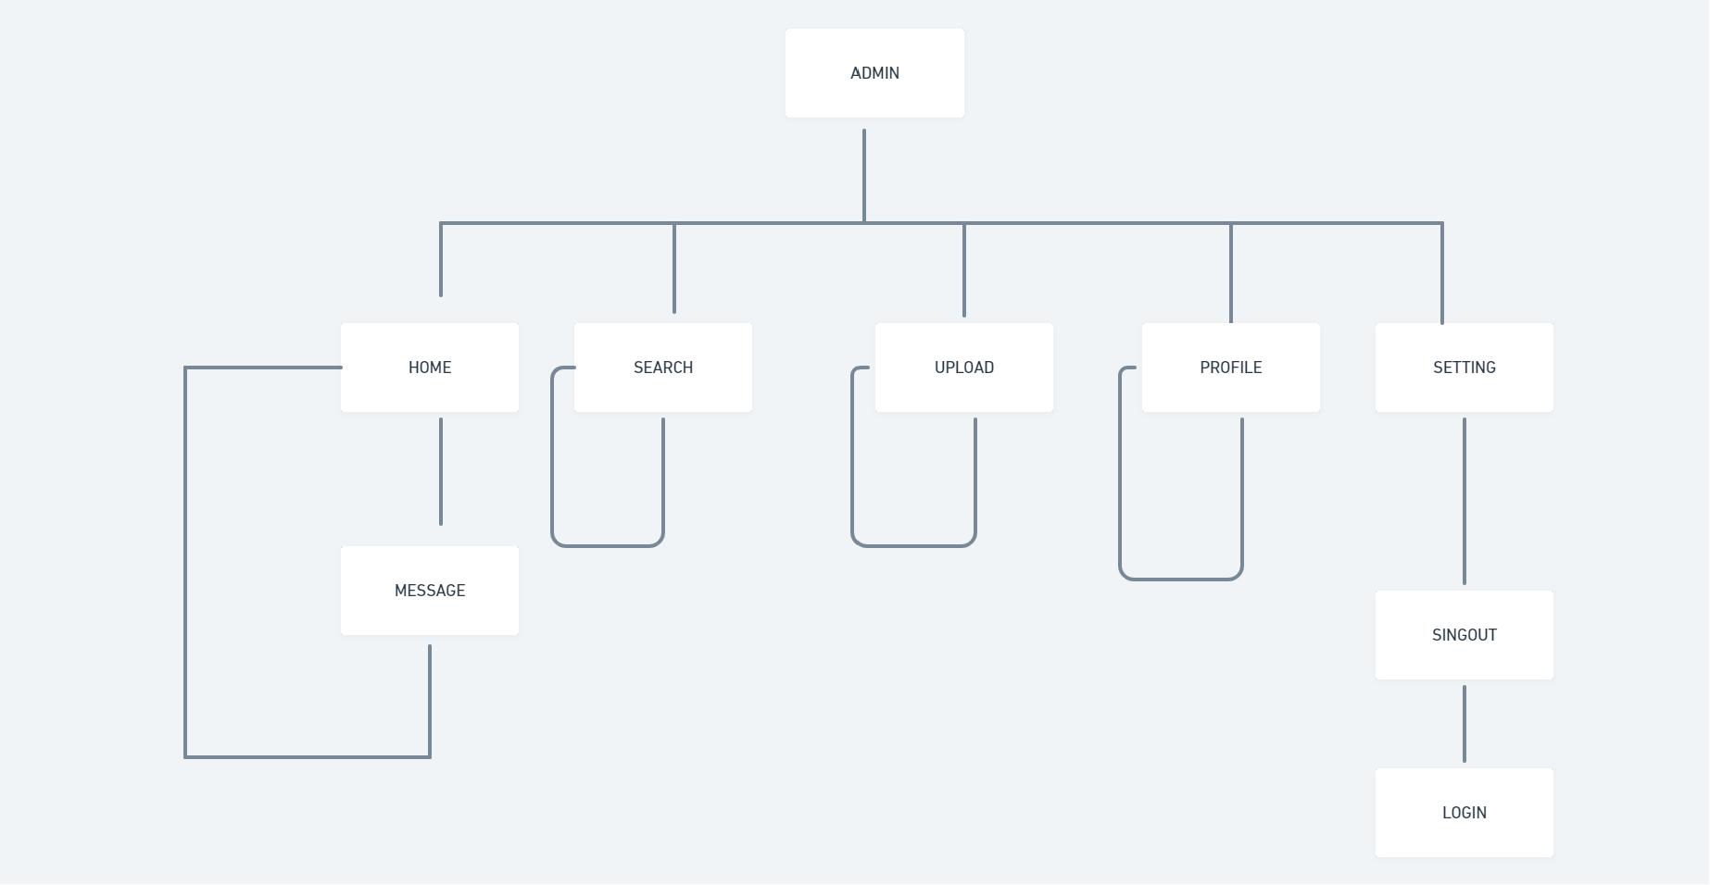

Hardware/Software Designing:

Hardware requirements for developing the app:

1. Processor: Intel i7 or More
2. Min. RAM: 16GB or More

Software requirements for developing the app:

1. Android studio
2. Flutter
3. Firebase for data connectivity

Applications:

**1. Versatile Implementation:**

* + The proposed solution is adaptable to a wide range of college environments, including universities, community colleges, and technical institutions.
  + Its flexibility ensures that it can cater to the unique needs and organizational structures of each institution.

1. **Tailored Customization:**
   * The application can be fully customized to align with the branding, visual identity, and overall aesthetics of each college.
   * This customization ensures that the application seamlessly integrates into the college's digital ecosystem while maintaining a cohesive look and feel.
2. **Event-Specific Customization:**
   * Beyond visual customization, the application can be customized to address specific event-related needs.
   * Colleges can prioritize features based on their unique focus, whether it's academic seminars, sports events, or cultural festivals.
3. **Event Feedback:**
   * The application includes a robust event feedback feature that allows colleges to gather insights and opinions from attendees.
   * Customizable feedback forms can be tailored to collect information on aspects that matter most to each college.
4. **Event Registration:**
   * The registration process can be adapted to meet the registration preferences of each college.
   * Custom registration forms can be created to capture essential information based on the type of event, whether it's a simple RSVP or a complex ticketing system.
5. **Social Networking:**
   * The application's social networking features foster connections and interactions among students.
   * Colleges can customize this feature to align with their specific goals, whether it's promoting student clubs, facilitating peer-to-peer networking, or encouraging engagement in campus activities.
6. **User Roles and Permissions:**
   * The application can be configured to accommodate the college's organizational structure, granting different levels of access and permissions to faculty, staff, students, and alumni.
7. **Integration with College Systems:**
   * Seamless integration with existing college systems, such as student information systems and learning management platforms, streamlines data sharing and enhances the application's utility.
8. **Accessibility and Inclusivity:**
   * Customization options ensure that the application adheres to accessibility standards and guidelines, catering to individuals with disabilities.
9. **Scalability:**
   * The solution can scale to meet the needs of colleges of different sizes, from small community colleges to large universities.
10. **Data Security and Compliance:**
    * Customized security measures and compliance with data protection regulations provide peace of mind for colleges and users.
11. **Training and Support:**
    * Colleges can access tailored training materials and ongoing support to effectively utilize and manage the application.

.

# Guided By: Group Members:

Prof. Vishal Trivedi Mr. Agam Jain(0827IT211010)

Mr. Aman Chaturvedi(0827IT211012)

Mr. Deepesh Sarathe((0827IT211032)

Miss. Khushi Panwar(0827IT211060)